**01416515 ROBOTICS LABORATORY 2**

Tello EDU Mini-Drone | Worksheet#1

(Dr. JUTARUT CHAORAINGERN RAI SIIE, KMIT’L)

**1. Tello Identification**

1. Propellers

2. Motors

3. Aircraft Status Indicator

4. Camera

5. Power Button

6. Antennas

7. Vision Positioning System

8. Flight Battery

9. Micro USB Port

10. Propeller Guards

**2. What is a quadcopter drone?**

Quadcopter drone is classified as a muti-rotor UAV which has 4 rotors to operate its tasks such as takeoff, rotate, landing, and move.

**3. Why do you learn Tello Drone?**

~~Because it is in the RAI curriculum~~

Tello Drone is a complete drone kid that provided a lot of sensing devices with it. Additionally, Tello Drone also supports various ways to wirelessly control it such as applications and python library. From all this stuff and software, it will allow me to understand drone controlling and sensing much easier. As a result, learning Tello Drone will expand my limitation of the idea to do the project.

**4. What is roll, yaw and pitch?**

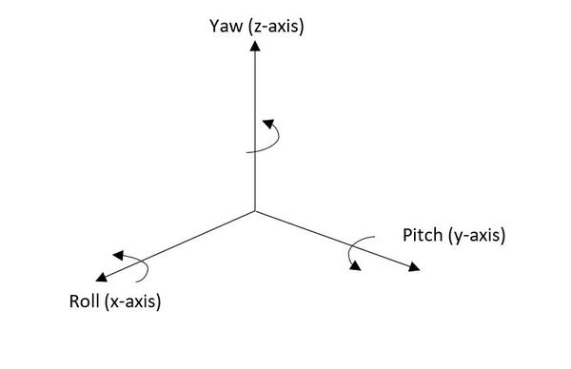Roll, Pitch, and Yaw are the rotation of the object around the 3D axis.

From above picture:

1. Roll is the rotation around X-axis.
2. Pitch is the rotation around Y-axis.
3. Yaw is the rotation around Z-axis.

**5. Who is responsible for setting rules for flying machines in Thailand?**

1. National Broadcasting and Telecommunications Commission (NBTC กสทช), which handles. the frequencies used by the drone.
2. Civil Aviation Authority of Thailand (CAAT), which registers all drone pilots.

**6. What are the rules concerning flying Quadcopter drones in Thailand?**

1. Weight of the drone:

- Greater than 2 kg must be registered

- Greater than 25 kg must receive permission from the minister of transport

1. Camera: every drone that has camera must be registered
2. High of flying: maximum of 90 m
3. Area of flying

- Not close to manned aircraft

- Not close to person, vehicle, and building at a distance less than 30 M horizontally.

- Not fly in restricted area

- Not fly within 9 km from airport

1. Controlling: must always be seen

**7. Write down the steps for starting a drone and control flight with Python.**

1. Download python 3.9.x onto the computer.
2. Download Code editor (PyCharm, VS code, Atom, etc.)
3. If you don’t use PyCharm, download virtual environment manager.
4. Create and Activate environment manager.
5. Install all dependence library into environment folder.
6. Open drone and connect to the drone’s local Wi-Fi.
7. Import Tello drone library in python, initialize Tello class, and use function connect.
8. To determine the movement of drone just read the doc of Tello drone library.

**8. Please Fill the Experimental results**

รูปภาพประกอบด้วย ข้อความ, ภาพหน้าจอ, ตัวอักษร, ไลน์

คำอธิบายที่สร้างโดยอัตโนมัติ

For Jupyter Notebook and note file:

For the result video:

9. Print 3D DJI Tello Ducted Propeller for using next week

รูปภาพประกอบด้วย เครื่อง, ในร่ม, เลื่อยไฟฟ้า, เครื่องมือ

คำอธิบายที่สร้างโดยอัตโนมัติ

Sir yes sir!!